Lesson Plan
Course Name – Python Game Development - Part 2(Pygame)
Lesson No –
Aim – Control a sprite in pygame using keys
Lesson Plan
1. Sprite is a character in the game
2. To create a sprite, first, we have to create a class that is of type Sprite (pygame’spredefined class). This class provides us many built-in functions that help in game development.
3. Syntax

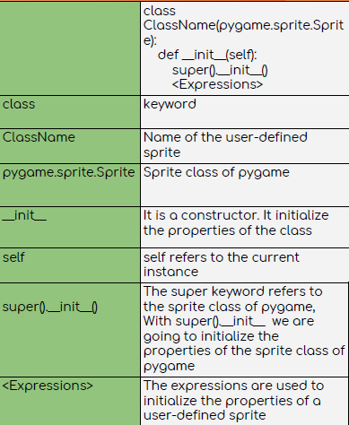

4. We can add some behaviour to the sprite by defining its update method., such as moving the sprite depending upn the keys pressed
4. Create a SpriteGroup:
A group of sprites is known as a sprite group. We use sprite groups when we have to do some manipulations on a collection of sprites.
5. Next Add the Sprite to the group
6. for the sprite , make the update method which helps in moving the sprite
7. For that we will use the move_ip method
This method moves the rectangle associated with the sprite by the offset supplied

